Chapter 14, Problem 92.

Using PSpice, plot the magnitude of the frequency response of the circuit in
Fig. 14.85.

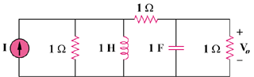

Figure 14.85
For Prob. 14.92.

